First form we can create User or Login

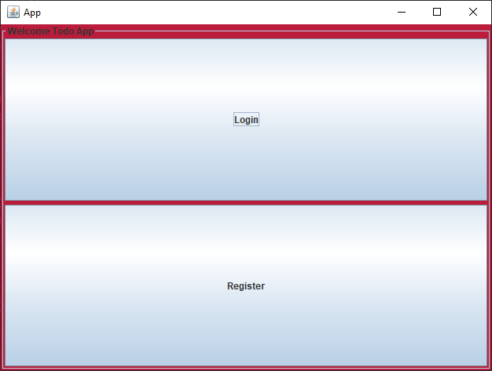

1. Create user

We click button “Register” to open form Register

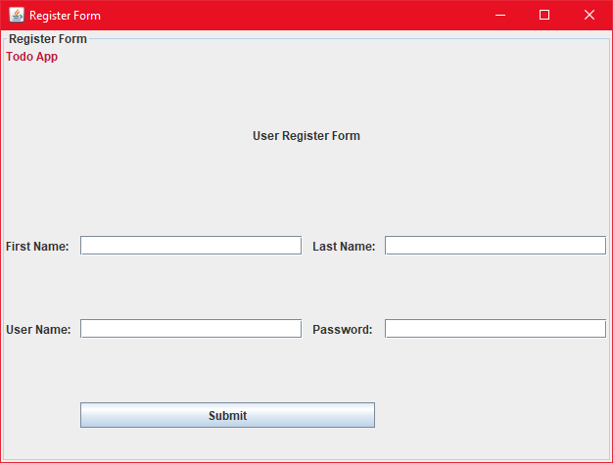

Enter your information.

1. Login

We click button “Login” to open form Login and enter your user name and password.

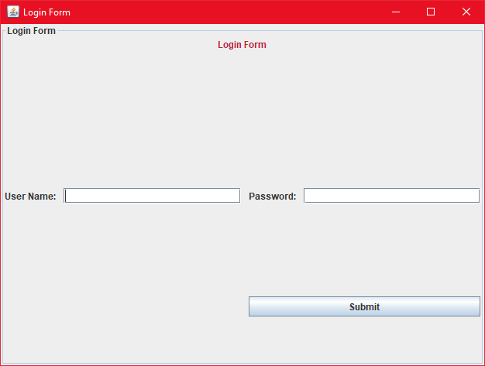

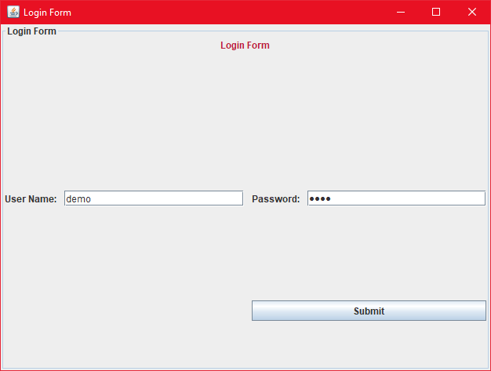

Click submit to login. After login successfully we have Todo List.

1. Todo List Form

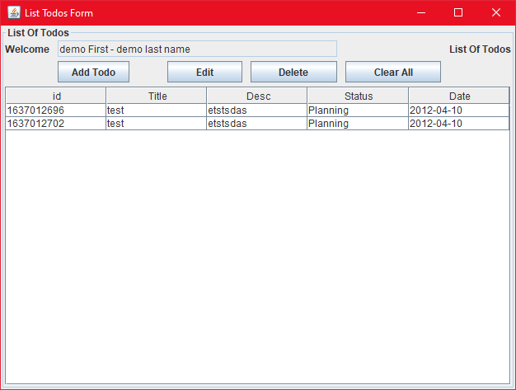

In todo List form we can add, edit, delete owner todo.

1. Form Add Todo

In this form we can enter Title, Description, Status and Due Date of to do.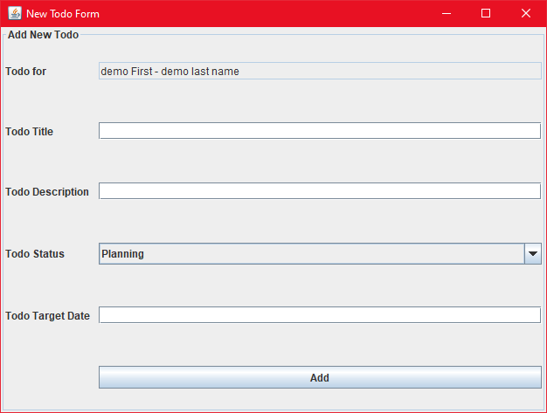

1. Form Edit Todo

